**Analytical Analysis of Saturation Output Power for   
Traveling-Wave Tube**

**Zhang Shen1, Hairong Yin1*, ShiRong Wang1, DongDong Jia1, Jun Cheng1, Yue Zhao1, Jin Xu1, Lingna Yue1, Guoqing Zhao1, W.X.Wang1,L.W.Liu2,Y.Y.Wei1**

1National Key Laboratory of Science and Technology on Vacuum Electronics

School of Electronics Science and Engineering

University of Electronic Science and Technology of China

Chengdu, Sichuan, 610054, China

2Anhui East China Photoelectric Technology Research Institute Co., Ltd.,Anhui,China

*E-mail: hryin@uestc.edu.cn

**Abstract:** *In order to predict the saturation output power of traveling wave tubes rapidly, analytical expression has been worked out. This theory is verified by comparison with two of large signal theory.*

**Keywords:** traveling-wave tube(twt); saturation output power; analytical expression.

## Introduction

When designing a TWT, it will save a lot of time if the saturation output power of the TWT can be predicted easily and rapidly before the more accurate calculation is carried out. This can be achieved with only a few simple parameters such as frequency, voltage, and current.

Since the power calculated by the small signal theory of the TWT is too rough[1], this paper presents an analytical expression of the saturation output power based on the analysis of the interaction between electrons and the electromagnetic wave. The expression is verified by comparison with two of large signal theory.

## Analytical analysis of the saturation output power for twt

As shown in Figure 1, when the twt is operating, the electromagnetic wave moves towards +z at the velocity *vp*. Initially, the electrons are uniformly distributed in the phase of the electromagnetic wave and move towards +z at the velocity *v0*, which is slightly higher than the *vp*.

Suppose the positive half of the electromagnetic wave is the deceleration field for the electrons, and the negative half is the acceleration field. The electrons in the acceleration region are accelerated by the electric field force and gradually move into the deceleration region while those which in the deceleration region are decelerated. Since *v0* is slightly greater than *vp*, the electrons in the deceleration region will still move forward some distance relative to the electromagnetic wave until their velocity reduce to the same as *vp*. In this way, the electrons uniformly distributed at the beginning will bunch in the deceleration region. To simplify the calculation, we assume that electrons are perfectly bunched, that is, the electrons cluster into a point, called "Ideal Bunch Point".

It is assumed that the initial position of the IBP is at the point *a* in Figure 1. Obviously, the point *a* is the upper bound of the initial position of the IBP. At this point the velocity of the IBP is assumed to be *vp*. Under the force of the deceleration field, the IBP will gradually decelerate, moving backward relative to the electromagnetic wave, giving up energy. The following analysis will ignore the energy exchange before the IBP formed. That is, we assume that the energy exchange between the electrons and the electromagnetic wave will start when IBP moves backward relative to the field from point *a*.

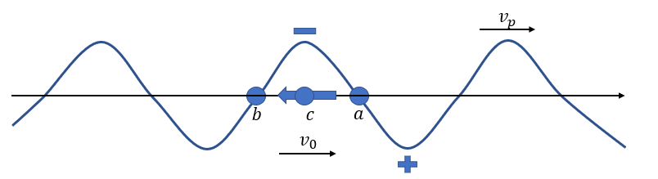

|  |  |  |
| --- | --- | --- |
|  | **Figure 1** |  |

Without relativity effect considered, based on conservation of energy, the saturation output power can be expressed as,

|  |  |
| --- | --- |
|  | (1) |

where *m* is the rest mass of electron, and *e* is the unit charge of electron, *v0* the initial speed of the electron, $\overline{v}$ the average speed of the electron after interaction, or the speed of the IBP after interaction, *Ic* the current of the IBP, *Ps0* the saturation output power. As when the IBP formed, there are some electrons in the deceleration region, and generally the IBP is not the case, the bunched current can be expressed by the operation current as,

|  |  |
| --- | --- |
|  | (2) |

In the equation (1), $\overline{v}$ and *Ps0* are unknown, thus we need another equation which includes these two parameters to get their values.

Let’s consider the motion of a single electron under the effect of the electric field, the motion equation is,

|  |  |
| --- | --- |
|  | (3) |

where *|E|* is the magnitude of the interaction electric field, $φ$ the phase of the interaction electric field. *|E|* can be expressed with the pierce impedance and the power on the circuit,

|  |  |
| --- | --- |
|  | (4) |

where $β$ is the slow wave number.

The average velocity change of the electrons before and after the interaction, or the velocity change of the IBP before and after the interaction, $\overline{v}$, can be written as,

|  |  |
| --- | --- |
|  | (5) |

In the process of interaction, the electric field force on every different single electron is different. Since we assume that the electrons are perfectly clustered, the electric field force on the IBP will be the average value of all the electrons that bunched in this point. Furthermore, the position of the IBP is different during the interaction, which means the magnitude and the phase of the interaction electric field will both be different. The effect of the phase varying can be expressed as a correction coefficient *C2*. As for the magnitude, we can use the average power on the circuit replace the *P* in (4), and name this value as *Pavg*. So $∆\overline{v}$ can be expressed by equation (3),

|  |  |
| --- | --- |
|  | (6) |

When the TWT is saturated, the IBP move to *b* from *a*., which means that the IBP has moved a half wave length realtive to the electromagnetic wave. But if the initial position of the IBP is not at the point *a* but at the left of *a*, the distance that the IBP moved will be smaller than a half wave length. In view of this factor, another correction coefficient *C3* is added. The relative time that the IBP in the deceleration region can be obtained by the distance and the average of the velocity change of the IBP, ${\overline{v}}_{avg}.$ The relationship between the ${\overline{v}}_{avg}$ and is,

|  |  |
| --- | --- |
|  | (7) |

*t* can be calculated by (7)，

|  |  |
| --- | --- |
|  | (8) |

From (6) and (8), we have,

|  |  |
| --- | --- |
|  | (9) |

the relationship of *Pavg* and *Ps0* is,

|  |  |
| --- | --- |
|  | (10) |

*C4* the correction coefficient of *Pavg* and *Ps0*. With (1) and (9), we finally obtain the expression of *Ps0* as,

|  |  |
| --- | --- |
|  | (11) |

*D*, which value is within the range of 1 to 4, is the combination of the *C1*, *C2*, *C3* and *C4* which are the correction of cluster current, the correction of the phase of the electric field, the correction of the magnitude of the electric field, the correction of P*avg*, respectively. The value of *D* can be determined by analytical analysis or experiment data.

## Verification of the theory

The following calculation assumes that the value of the operation voltage is the perfect synchronized voltage.

Figure 2. shows the comparison of the saturation output power calculated by the theory presented in this paper and a 2D large signal theory[3] for a 6-18 GHz helix twt. In Figure 2, the *P1* and *P2* are the results of this theory, when *D* is set to be 1 and 4, respectively. *P3* is the result of the 2D large signal theory. As can be seen from Figure 2, the results of the 2D large signal theory is within range when *D* varies from 1 to 4.

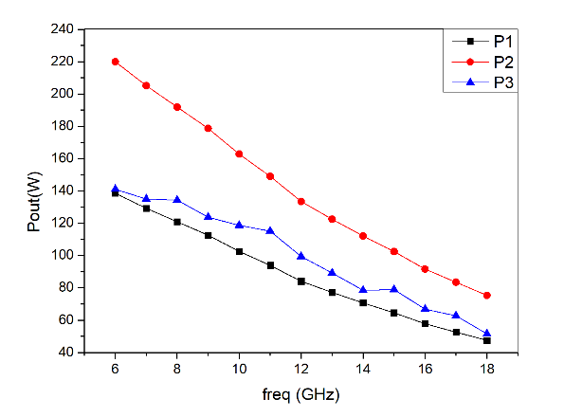

|  |  |  |
| --- | --- | --- |
|  | **Figure 2** |  |

For a 71-76 GHz folded waveguide twt[2], the output power calculated by this theory and a 1D large signal theory[4] are shown in Figure 3. In Figure 3, the *P1* and *P2* are the results of this theory, when *D* is set to be 1 and 4, respectively. *P3* is the result of the 1D large signal theory. As can be seen from Figure 3, the results of the 1D large signal theory is within range when D varies from 1 to 4.

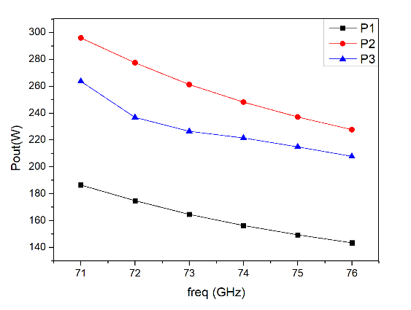

|  |  |  |
| --- | --- | --- |
|  | **Figure 3** |  |

## Conclusion

The analytical expression of saturation output power has been worked out. It has been verified by comparison with two of large signal theory. The power obtained from the large signal theory is within range when *D* varies from 1 to 4.

**Acknowledgements**

This work was supported in part by the National Natural Science Foundation of China under Grant NO.61771117.

## References

|  |  |
| --- | --- |
| [1] | J.R.Pierce, “Theory of the Beam-Type Travelling Wave Tube”, PIRE, 35(1947),2:111. |
| [2] | K. Chen, X. Zhou, T. Tang, J. Xu, H. Gong and X. Su, "A 94–96GHz 100 watts folded waveguide TWT," 2017 IVEC, London, 2017, pp. 1-2.doi: 10.1109/IVEC.2017.8289737 |
| [3] | A. M. Katz, E. M. Il’in, and I. A. Mankin, Nelineynii yvleniav SVCH priborach O-tipas dlitelnim vzaimodeystviim (Nonlinear phenomena in high frequency O-type devices with distributed interaction) (in Russian). Moscow: Soviet Radio, 1975. |
| [4] | DD Jia, “1D large signal theory,” unpublished. |